Abstract Title (Arial 14 bold, Space after paragraph: 18pt)
1. Author: Title. First, Last name (Arial 12 bold)
Company / University / Institute, Street #, ZIP-Code City, Country, E-mail: email@company.com
(Arial 10, space after paragraph: 12pt))
Co-Authors: Title. First, Last name, Title. First, Last name, Title. First, Last name (Arial 12 bold, space after paragraph: 12pt)
This document is an instruction on how to write a scientific abstract for the 14th IFK 2024 in Dresden. The structure of this instruction follows the format proposal for submission. The abstract should include the following information:
2 cm
2,5 cm

- State of art / Research objective
- Level of novelty / innovation
- User benefit
- Validation / Maturity level / Results
All abstracts for the 14th IFK shall be written in English. Please register and submit the abstract online in pdf form under https://www.conftool.pro/ifk2024/ by June 18, 2023. The abstract length is limited to a maximum of 2 pages / 300 words.
The standard font type is specified as Arial 12pt, justified. The required line spacing is 1.5 with a space of 6pt after each paragraph.
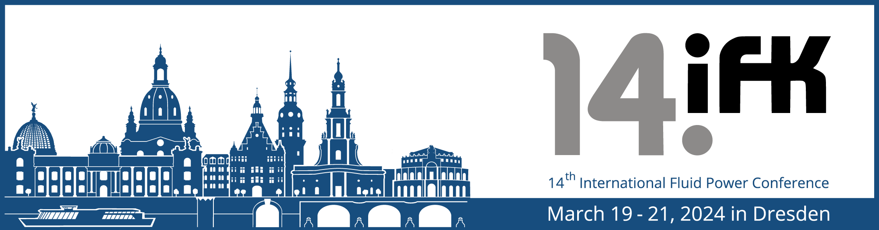
Figure: 14th IFK (Arial 12)
2,5 cm
You can reinforce the statement of your abstract with a (maximum of) one figure, which you may insert at any suitable point within the abstract. Do not put it at the end! The resolution of the picture should be at least 300 dpi.

